C:\Users\Mostafa\Desktop\nameplate.jpg

Embedded systems Project

Heart Monitor

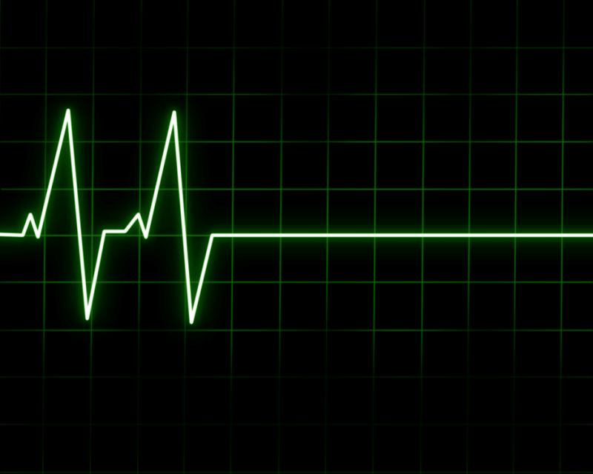

Introduced to: Dr. Shalan

By: Khloud Maged Helmi

ID: 900162914

**Table of Contents**

1. Introduction
2. Project description
3. Components and Tools
4. Background
5. Design
6. Procedures
7. Results

**Introduction**

Heart diseases is one of the leading causes of death worldwide. Medical technology has been researching ways to improve Electro – Cardiogram (ECG) to help out millions of people around the world suffering every single day from these diseases. The main tool to find out the health of patient’s health is still unclear, but by working more and more on ECG in the past few years, a large machine could be replaced by a small app working from home using sophisticated techniques. This app could be used to check on the patient and record his/her own heart activity over a period of time in a day and this will help to reduce the time the patient spends in the hospital and will create his/her repots always without a direct contact with the hospital.

So, the goal is just developing a USB Based ECG Portable system and displayed the acquired ECG signal and pass it to a PC using print screen to get the data in graph form and this process needs: an available microcontroller, an Analog circuit, Universal serial bus technology, an automated ECG Signal analysis will give a report of an individual.

Recently many studies show that heart diseases are the most leading cause of death annually. And most research efforts have been focusing on the ECG feature extraction using standard databases and having analyzed the existing solutions. Keep up with the trend of USB health care, the desired app, that will be built, has been given a feasible solution that is reliable, portable, easy to use with good power efficiency. This will help the heart disease patient to have continuous updates about his/her medical issue from home.

**Project description**

The purpose of this project is to build a simple embedded application using the STM32 module and the ECG sensor to collect ECG signal and report it to a PC over USB link for displaying and further analysis. I am using a Nucleo-32 as a type of Microcontrollers, and in details, the one is used here in this project is STM32L432KCU6 and a heart sensor to get some values and display them in graph form.

Moreover, this app should accept from the user, which will be the patient in this case:

• Command for getting the sampling rates.

• Command for collecting 1-minute worth of data.

• Command for reporting the heart beat rate in (bpm).

And these commands entered in python interface and they are just kind of interrupts in the UART that get handled in the embedded code part.

**Components & Tools**

* STM32L432KCU6 32 PINS
* AD8232 Heart Rate Monitor.
* Breadboard & Wires.
* LED to get some indication about the validity of the system.

**Background and definitions**

**STM32L432KCU6**

The STM32L432KCU6 devices embed high-speed memories (Flash memory up to 256 Kbyte, 64 Kbyte of SRAM), a Quad SPI flash memories interface and an extensive range of enhanced I/Os and peripherals connected to two APB buses, two AHB buses and a 32-bit multi-AHB bus matrix.

**AD8232 Heart Rate Monitor**

The Heart Rate Monitor consists of 3 electrodes to collect the ECG signal (sensors) and a small board that performs signal conditioning. The Heart Rate Monitor is designed to extract, amplify, and filter small bio potential signals in the presence of noisy conditions, such as those created by motion or remote electrode placement. And it will be a main component in this application.

**ECG**

ECG which stands for Electro – Cardiogram is the process of recording the electrical activity of the heart over a period of time using electrodes placed over the skin. These electrodes detect the tiny electrical changes on the skin that arise from the heart muscle's electro physiologic pattern of depolarizing and repolarizing during each heartbeat. This is the most efficient process that performed to detect any cardiac problems, being built in an app for this usage.

**How the design looks like:**

The design consists of ECG sensor with electrodes, (amplifier and filtering which is the signal conditioner) and this is already done explicitly in this kind of sensor “AD8232“, (ADC analog to digital converter and this will be done in the microcontroller. PC is also used to analyze the data and draw the calculate data and sampling rates.

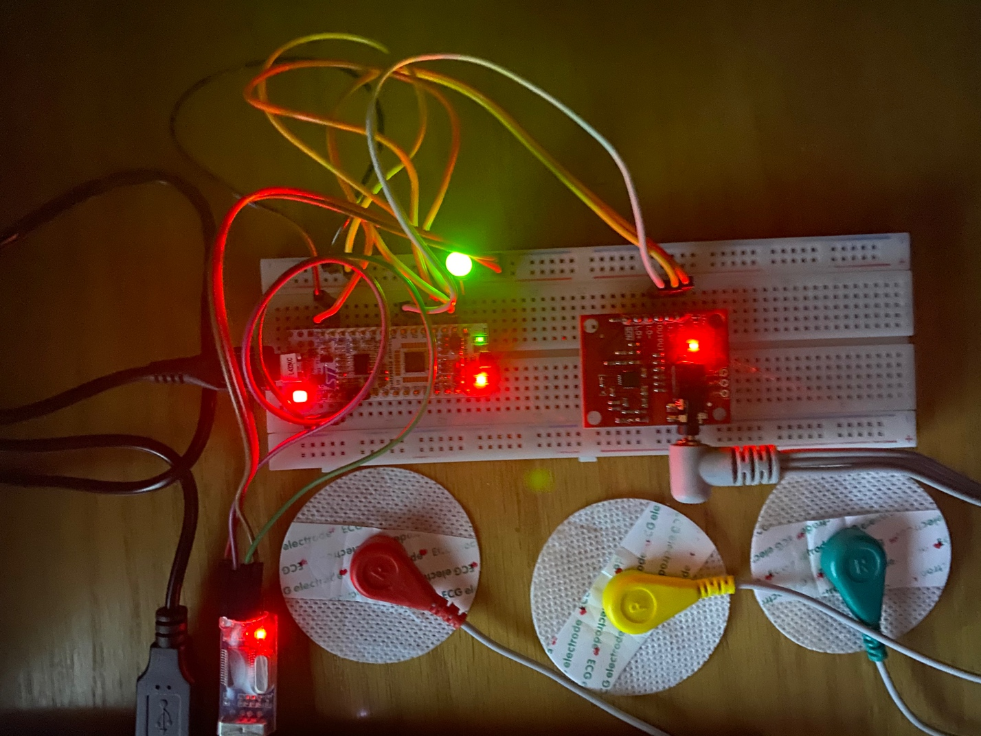

**Procedures:**

• Get familiar with the ECG signal used to monitor the heart activities.

* Use the STM32L432KCU6 microcontroller to get Analog to Digital Converter (ADC) conversion done.
* Use the UART to communicate ECG data to a remote PC for further processing and analyzing the data in graph design.

How the code is implemented:

Implemented in the embedded code some kind of infinite loop that keep getting the sensor reads and then pass them to the ADC which stands for analog to digital converter which is intiACD(); function in the code, the idea is just convert the analog data that comes from the heart sensor and get it in digital form so the microcontroller can recognize it.

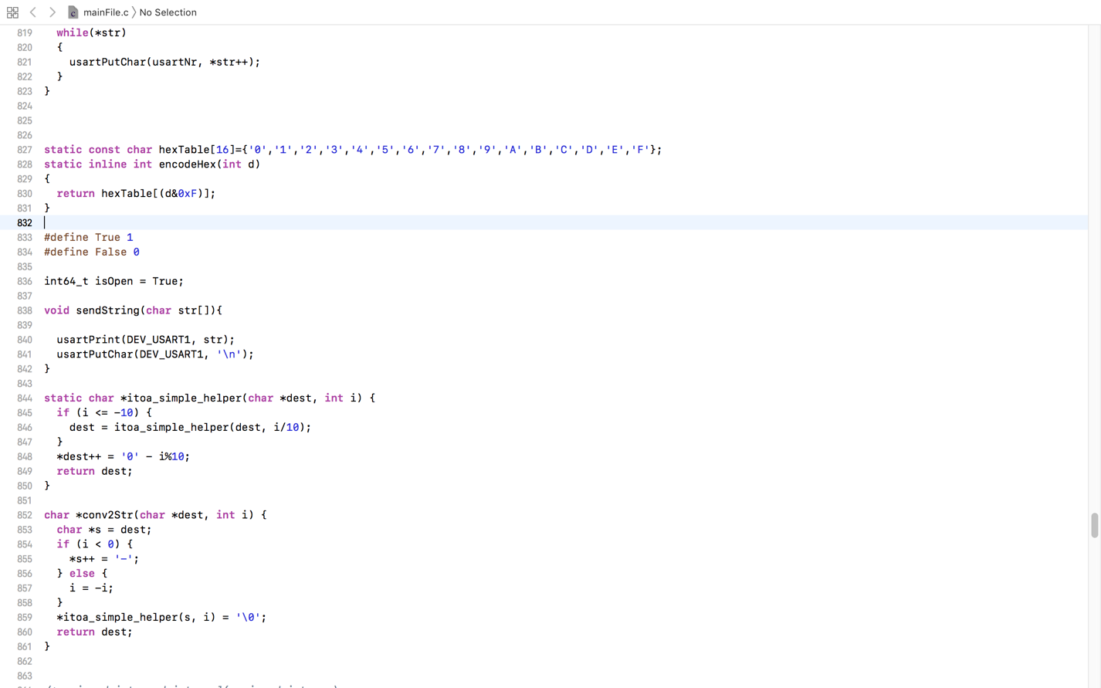

intiACD();

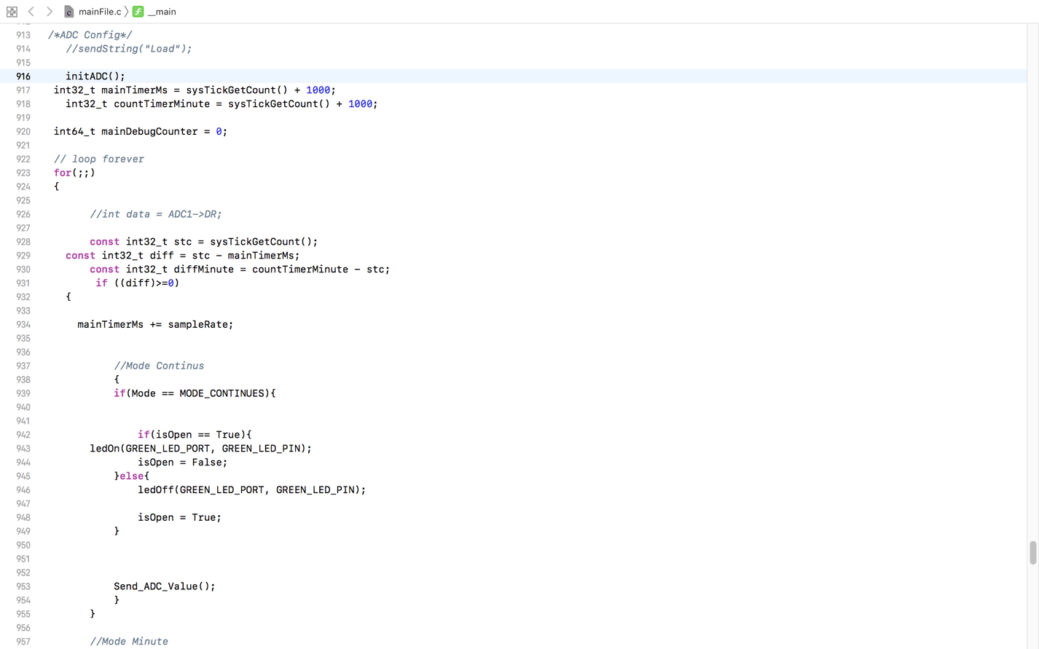

The embedded code is build according to the registers level and referenced to the datasheet for this specific microcontroller Nucleo-32 (STM32L432KCU6).

Note that the conversion does not work all the time, ADC starts conversion once the sensor starts to read and the analog data is ready now. The sampling rate depends mainly on the maximum frequency and the maximum transmission rate, and by knowing that the ADC has a 1MHZ and it is so much. ECG signals will be limited to 2000 Hz to 2500 Hz. So, a sampling frequency of 5000 Hz will be perfect for high-frequency signals detection. Then we look for the baud rate and the default value is 9600 but this is not enough for the accuracy of the sampling rate we are looking for so I stepped it up till 115200.

Sampling rate in the embedded code is changed according to a timer, this timer has a load value and by changing this load value we can change the cycle for the timer, then the timer every cycle triggers the ADC to read or send the data.

**Requirements:**

we have three modes or (Commands) that the user can enter in the python interface:

* Command to set the sampling rate.

In this mood, the user can select a desired value for the sampling rate and get the data in a graph form according to this selected value.

* Command to collect a worth of data after one minute.

In this mood, the user request to get the data after 1 minute, in other words, we collect the data from the sensor of one complete minute and then convert it and stored it then after 60 seconds which is the one minute we consumed it, the data is ready to be sent to the user and appear on the screen in the graph form.

* Command to get the heart beat rate (bpm).

In this mood, the user asks for the heart beat rate and this is calculated in the frontend code which is the python by using the collected data from the sample rate and a lib used for this in python called: ‘heartpy as hp’. In general, the bpm is calculated by getting the average of the peaks per second.

**Results:**

Example graphs to show the outputs:

In the graphs, the voltage is represented by the y-axis and the time is represented by x-axis.

In the following image, I am using the first mood (continuous) for setting the sampling rates and as shown I select the sample rate to be: 500Ms.

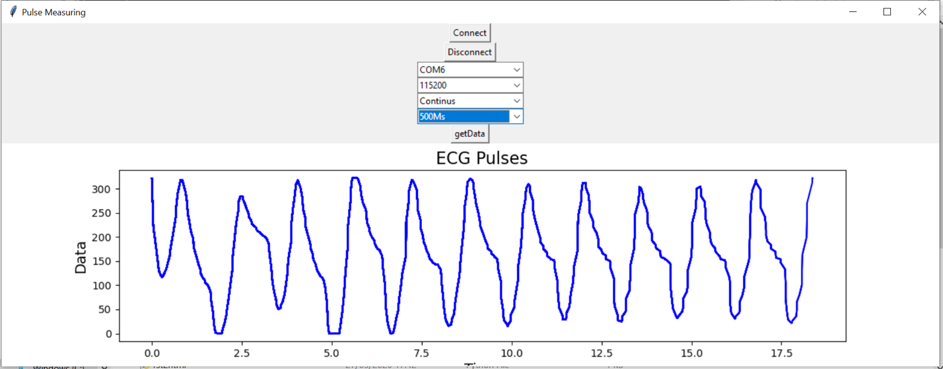

With different position for the electrodes:

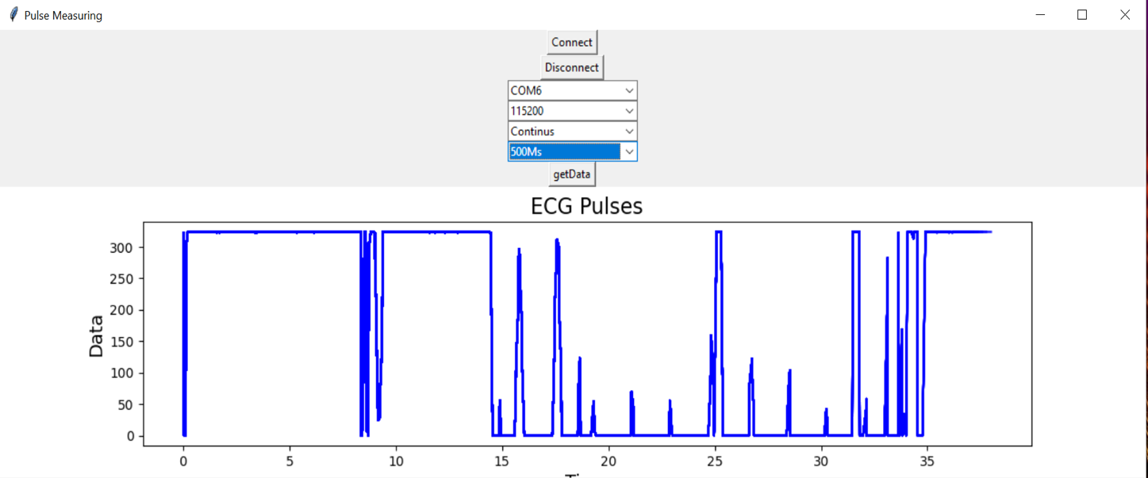

In the following image, I am using the second mood (Minute of readings) for collecting 1 minute of worth data and as shown the sample rate is selected to be: 100Ms.

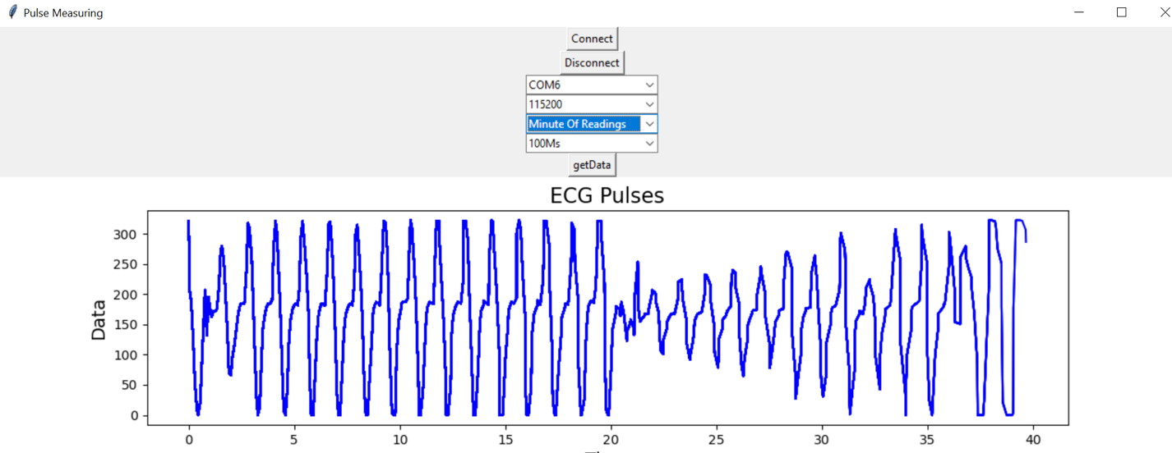

**Conclusion**

In this project, we built a small embedded application to monitor the heart pluses and beat rate. The goal is just developing a USB Based ECG Portable system and displayed the acquired ECG signals which is analog signals and convert them to digital signals in the used microcontroller (Nucleo-32 (STM32L432KCU6) and then passing these signals which will be the required data to a PC universal serial bus technology to get this data in graph form and by then any user who will be the patient in this case will get a complete report of their heart activities.

Github repo:

<https://github.com/5o5o/Heart-Monitor-Embedded-Project>